- List entire contents of the Customers table
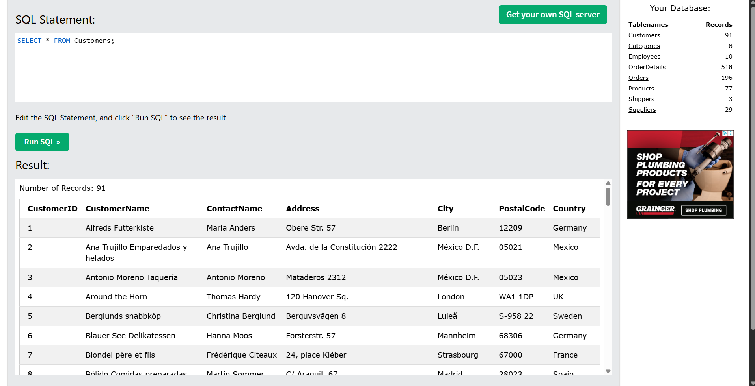
- List the CustomerName of all customers where city = "Berlin”
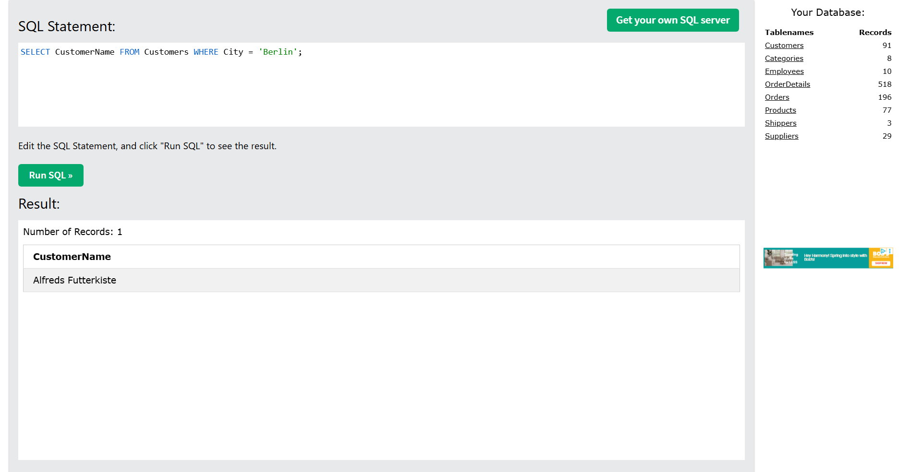

- List the CustomerName of all customers in the USA in alphabetical order by CustomerName
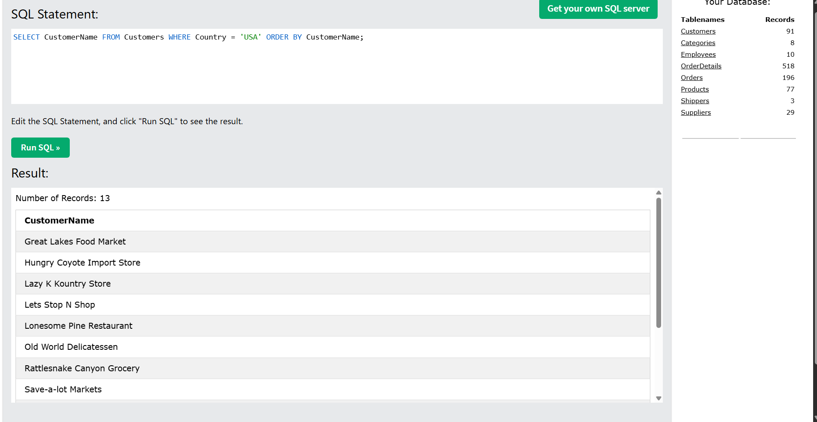
- Part 1 - List all of the cities in the Customers table
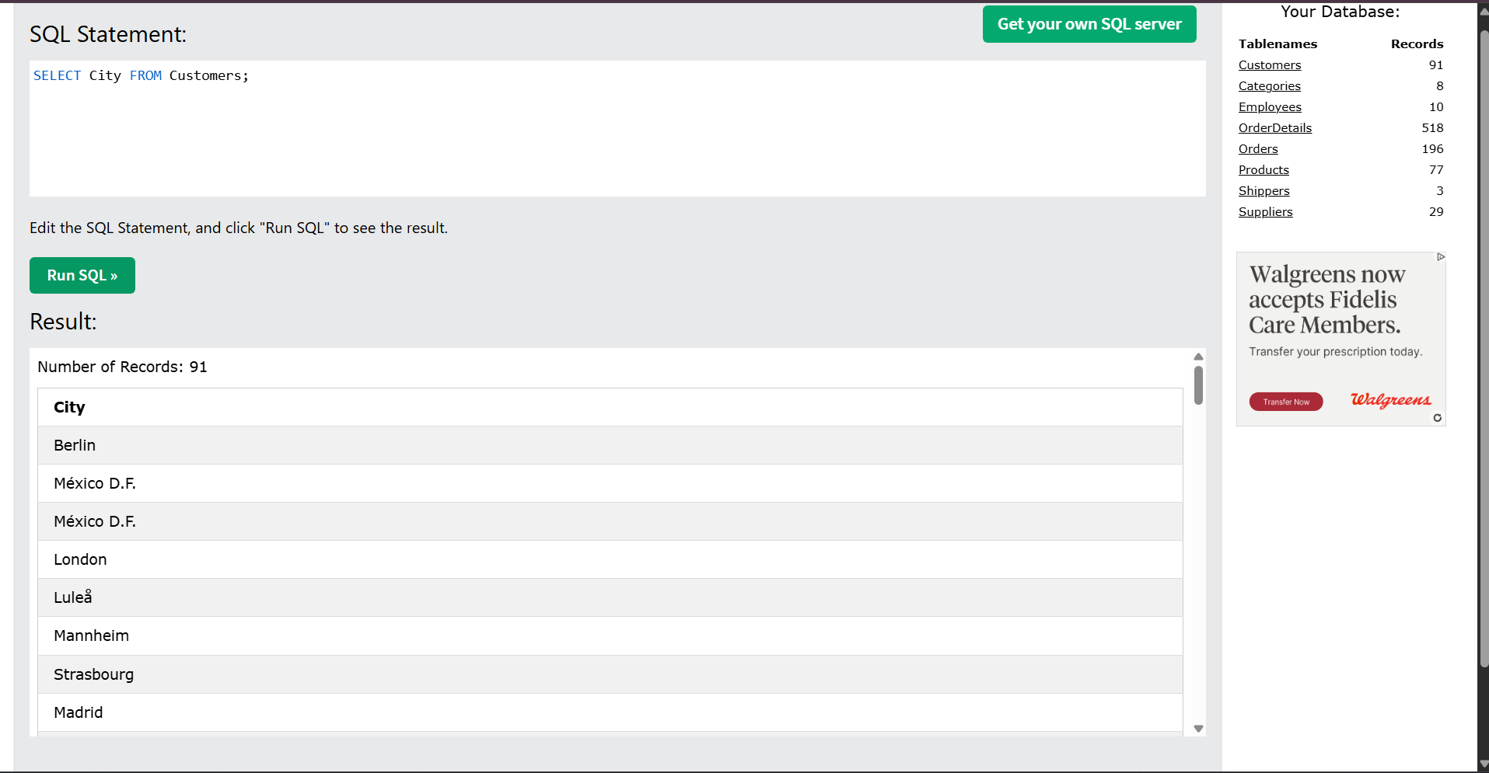

Part 2 - Now revise your SQL to remove duplicate cities.
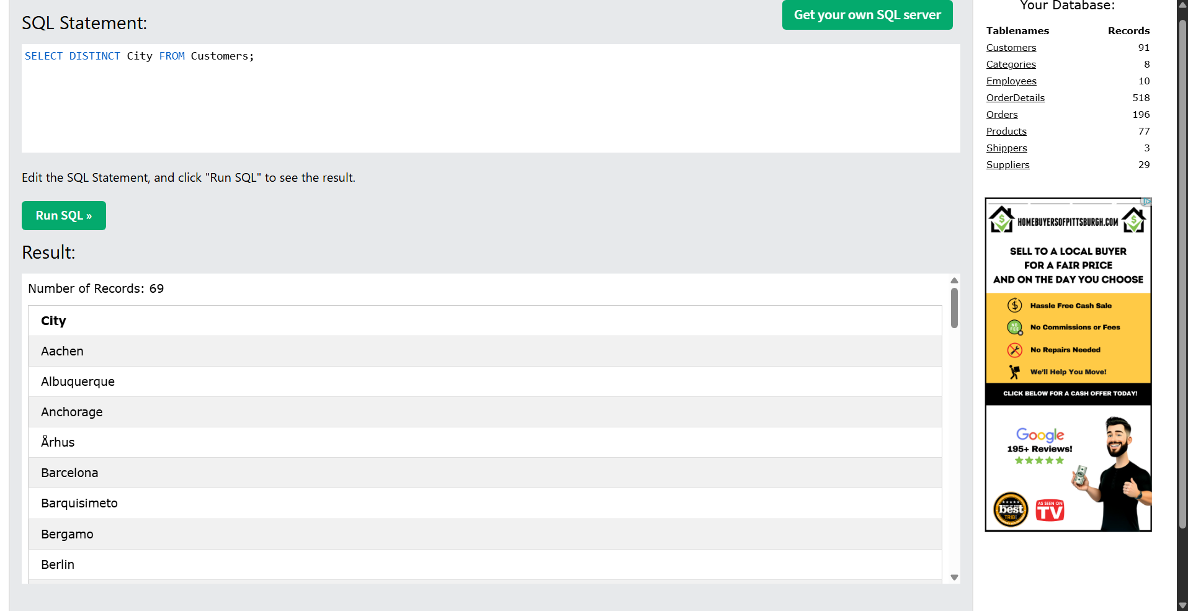
- I could not get this one to allow me to edit it. Only gives me an error because the INSERT permission is denied
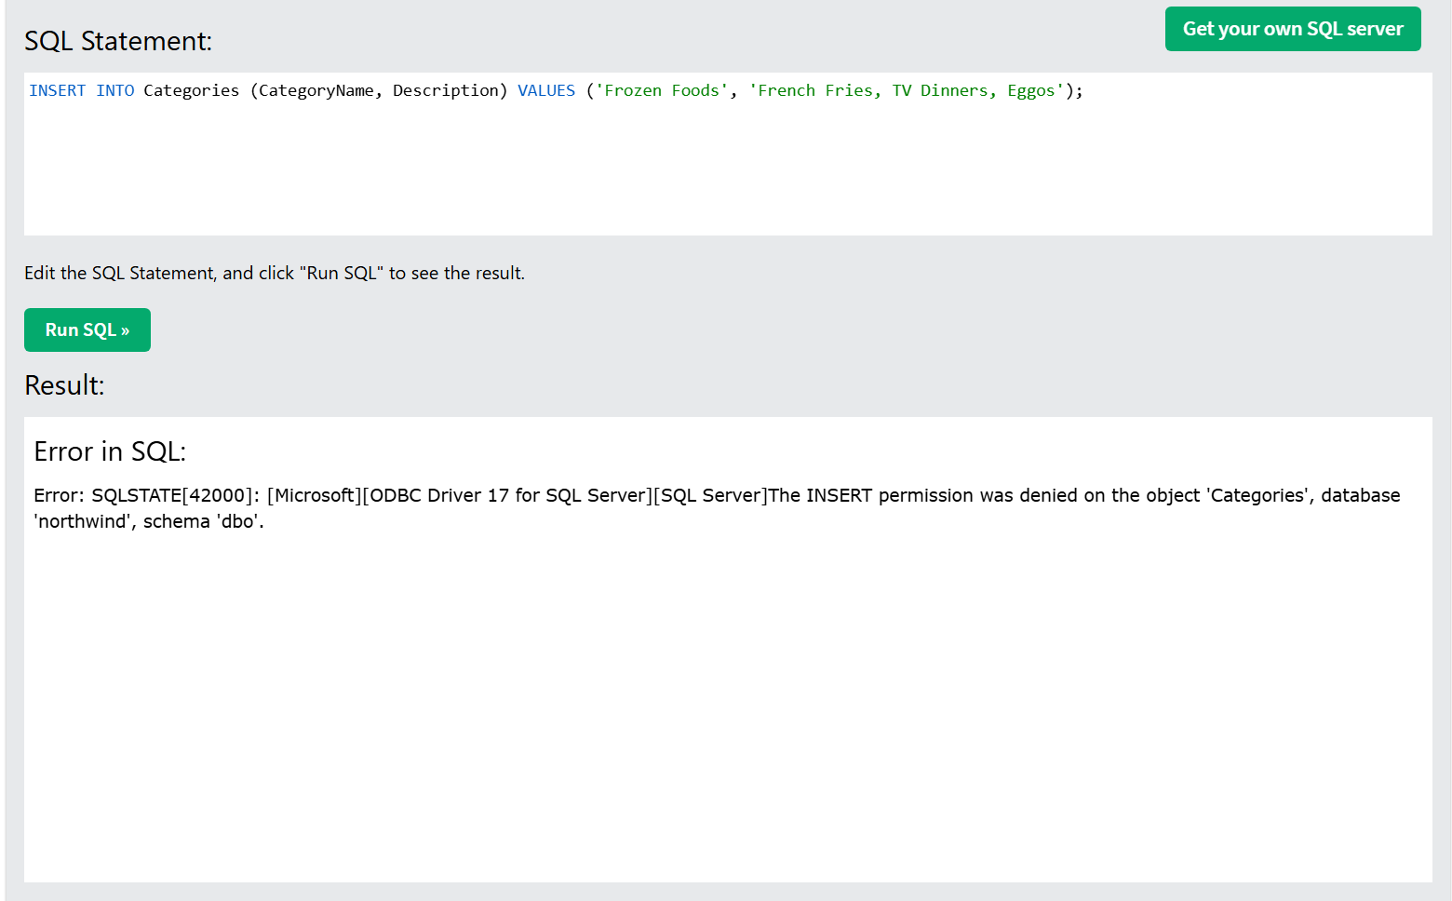

- The same error occurs with deleting anything as well.
